Bean Scopes

It generally tells :

1. Scopes refer to the life cycle of the bean.
2. How long does the bean live?
3. How many instances are created?
4. How is the bean shared in the spring environment?

**Default Scope (singleton)**

In this case the spring container will create only one instance of the bean, by default. The same bean is cached in memory. All request to the bean will return the shared reference to the same bean.

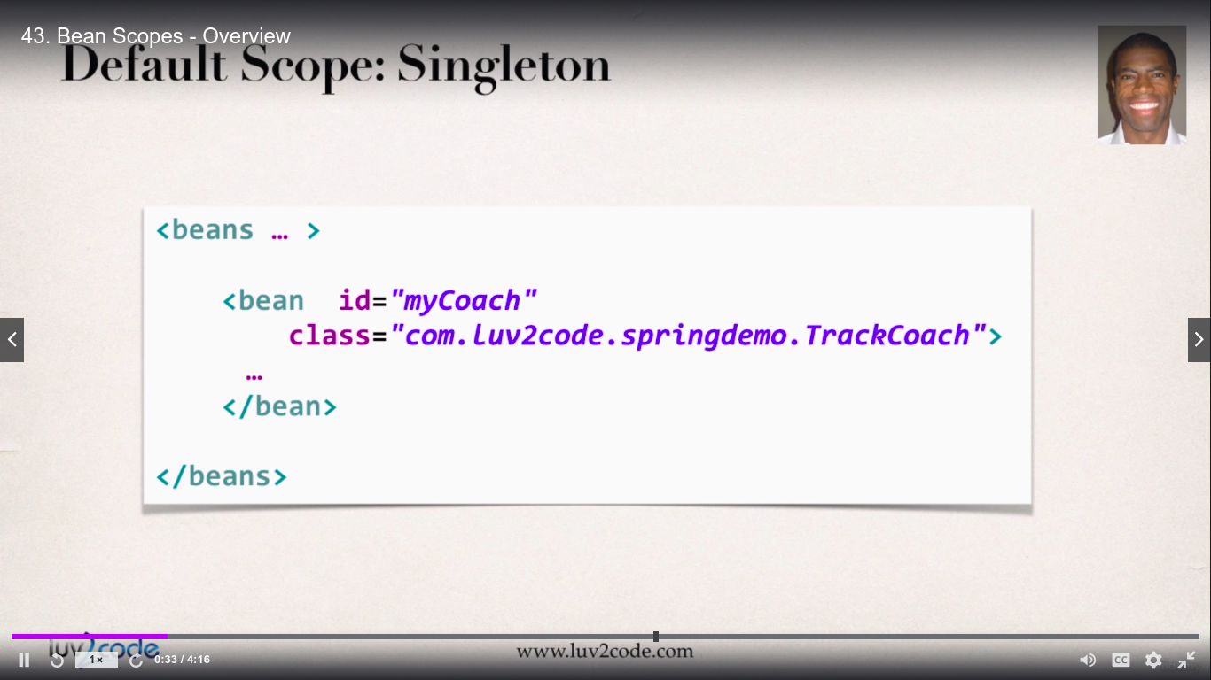

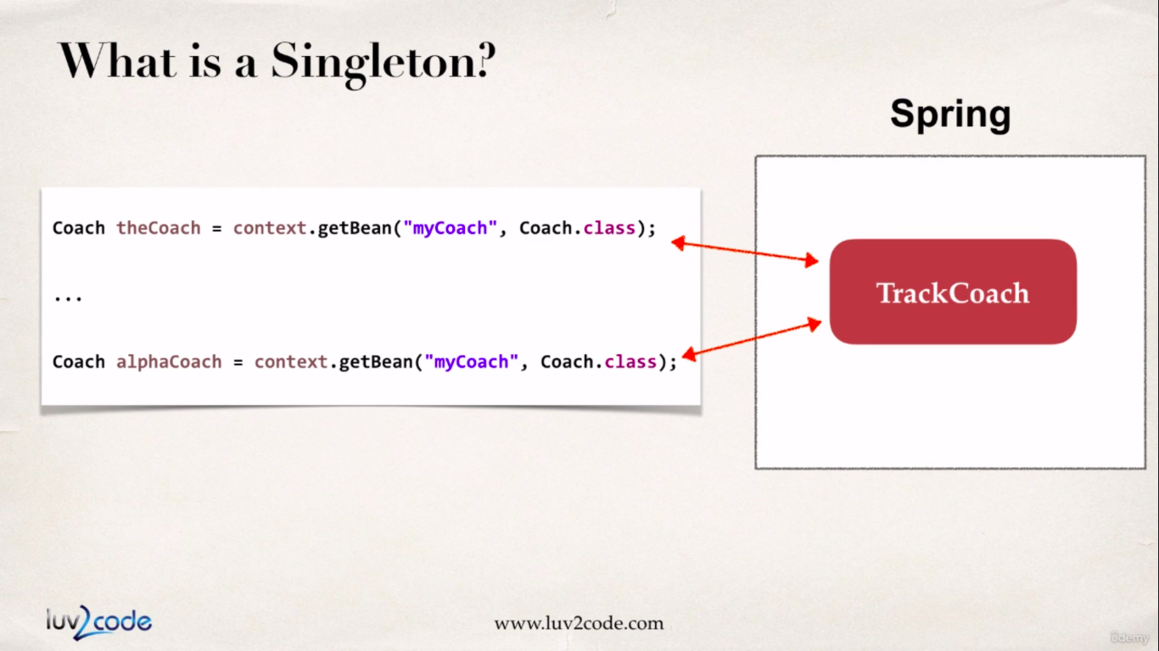

In the diagram above both “alphaCoach” and “theCoach” will have a shared reference. This is a typical use case if we want to make use of stateless beans.

How ever, we can explicitly mention the scope type in the xml config file with ‘scope’ attribute as shown below :

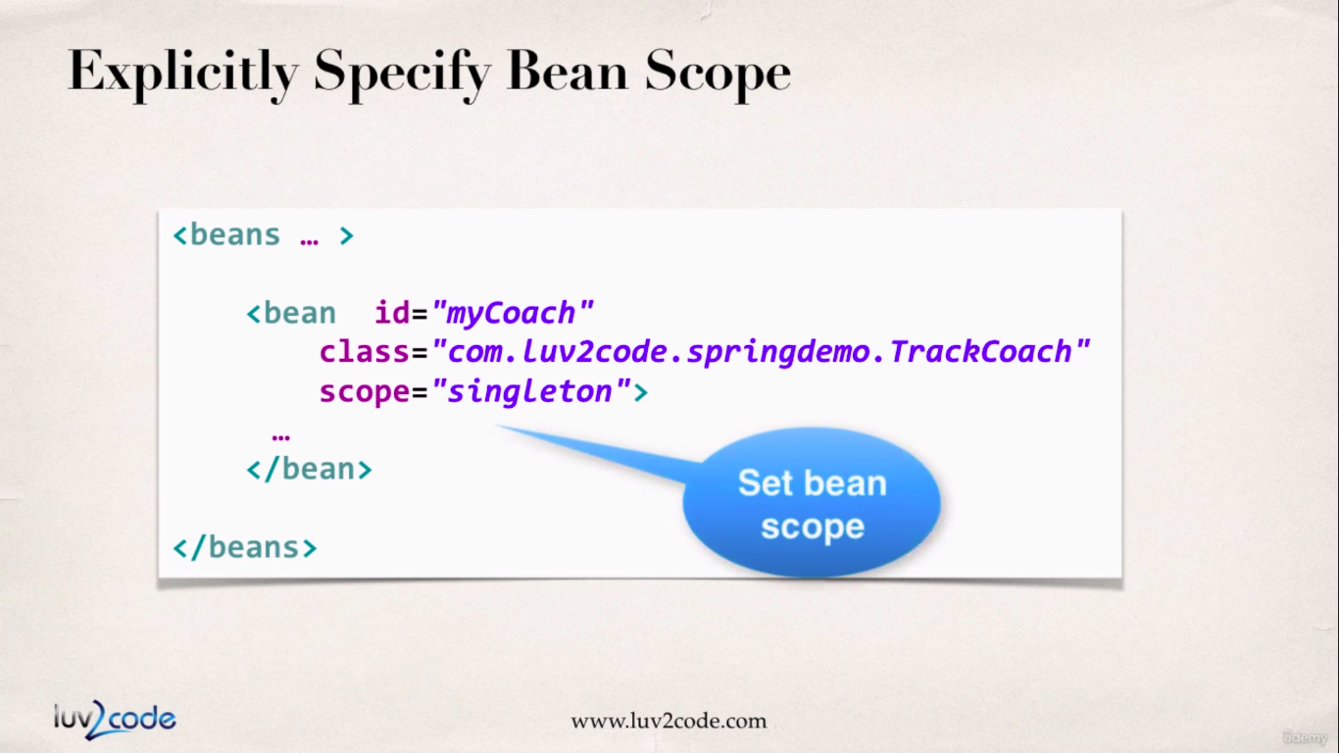

Let’s look at the example below :

**applicationContextSetterInjection.xml (xml config file)**

<?xml version=*"1.0"* encoding=*"UTF-8"*?>

<beans xmlns=*"http://www.springframework.org/schema/beans"*

xmlns:xsi=*"http://www.w3.org/2001/XMLSchema-instance"*

xmlns:context=*"http://www.springframework.org/schema/context"*

xsi:schemaLocation=*"http://www.springframework.org/schema/beans*

*http://www.springframework.org/schema/beans/spring-beans.xsd*

*http://www.springframework.org/schema/context*

*http://www.springframework.org/schema/context/spring-context.xsd"*>

<!-- Define your beans here -->

<!-- dependency bean -->

<bean id=*"myFortuneBean"*

class=*"com.busybox.setterInjection.HappyFortuneService"*></bean>

<!-- define bean injection as singleton, which is implicit -->

<bean id=*"myCoach"* class=*"com.busybox.setterInjection.TrackCoach"*

scope=*"singleton"*>

<!-- setup setter injection -->

<property name=*"fortuneService"* ref=*"myFortuneBean"*></property>

</bean>

<bean id=*"baseBallCoach"*

class=*"com.busybox.setterInjection.BaseBallCoach"*>

<!-- setup setter injection -->

<property name=*"fortuneService"* ref=*"myFortuneBean"*></property>

</bean>

<!-- load the property file -->

<context:property-placeholder

location=*"classpath:sport.properties"* />

<bean id=*"cricketCoach"*

class=*"com.busybox.setterInjection.CricketCoach"*>

<!-- set up setter injection -->

<property name=*"fortuneService"* ref=*"myFortuneBean"*></property>

<!-- injection for email id literal value -->

<!-- <property name="emailAddress" value="busyboxhere@gmail.com"></property> -->

<!-- injection for phone number literal value -->

<!-- <property name="phoneNumber" value="8847848036"></property> -->

<property name=*"phoneNumber"* value=*"${phoneNumber}"*></property>

<property name=*"emailAddress"* value=*"${emailAddress}"*></property>

</bean>

</beans>

**SetterInjectionDriver.java :**

**package** com.busybox.setterInjection;

**import** org.springframework.context.support.ClassPathXmlApplicationContext;

**public** **class** SetterInjectionDriver {

**public** **static** **void** main(String[] args) {

ClassPathXmlApplicationContext context = **new** ClassPathXmlApplicationContext(

"applicationContextSetterInjection.xml");

Coach trackCoach = context.getBean("myCoach", TrackCoach.**class**);

// check for single tone scope by comparing trackCoach1 and trackCoach2

Coach trackCoach1 = context.getBean("myCoach", TrackCoach.**class**);

Coach trackCoach2 = context.getBean("myCoach", TrackCoach.**class**);

Coach baseballCoach = context.getBean("baseBallCoach", BaseBallCoach.**class**);

CricketCoach cricketCoach = context.getBean("cricketCoach", CricketCoach.**class**);

System.***out***.println(trackCoach.getDailyWorkout());

System.***out***.println(trackCoach.getDailyFortune());

System.***out***.println(baseballCoach.getDailyWorkout());

System.***out***.println(baseballCoach.getDailyFortune());

System.***out***.println(cricketCoach.getDailyWorkout());

System.***out***.println(cricketCoach.getDailyFortune());

System.***out***.println(cricketCoach.getEmailAddress());

System.***out***.println(cricketCoach.getPhoneNumber());

System.***out***.println("is trackCoach1==trackCoach2 ==> " + (trackCoach1 == trackCoach2));

// is trackCoach1==trackCoach2 ==> true

System.***out***.println("trackCoach1 memory address : "+trackCoach1);

// trackCoach1 memory address : com.busybox.setterInjection.TrackCoach@2e6a8155

System.***out***.println("trackCoach2 memory address : "+trackCoach2);

// trackCoach2 memory address : com.busybox.setterInjection.TrackCoach@2e6a8155

context.close();

}

}

As we can see from the output the different beans point to same memory address.

**Prototype Scope :**

In this type of scope, we will get a new instance of bean every time we request a bean.

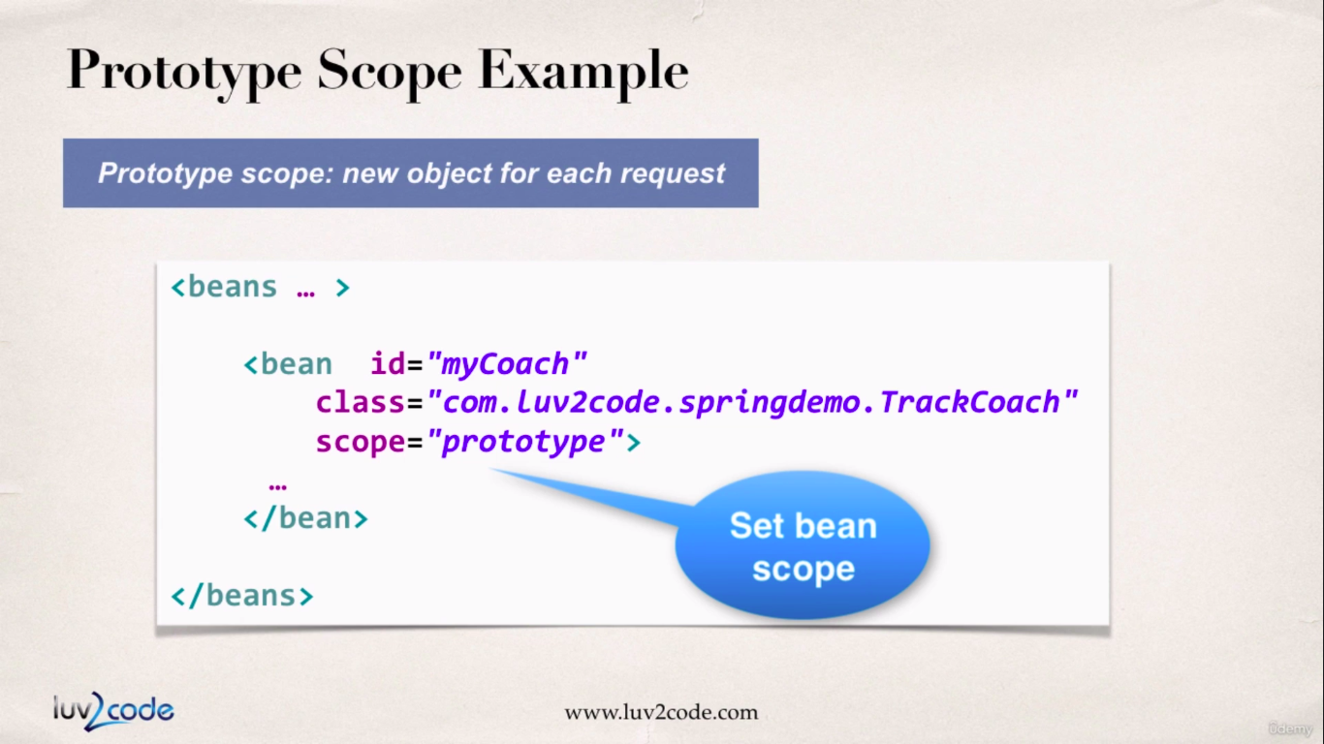

So, every time we make a request for an object of ‘TrackCoach’ we will get different beans every time. This example is illustrated below :

As we can see the diagram below, we have two different ‘TrackCoach’ objects in the memory.

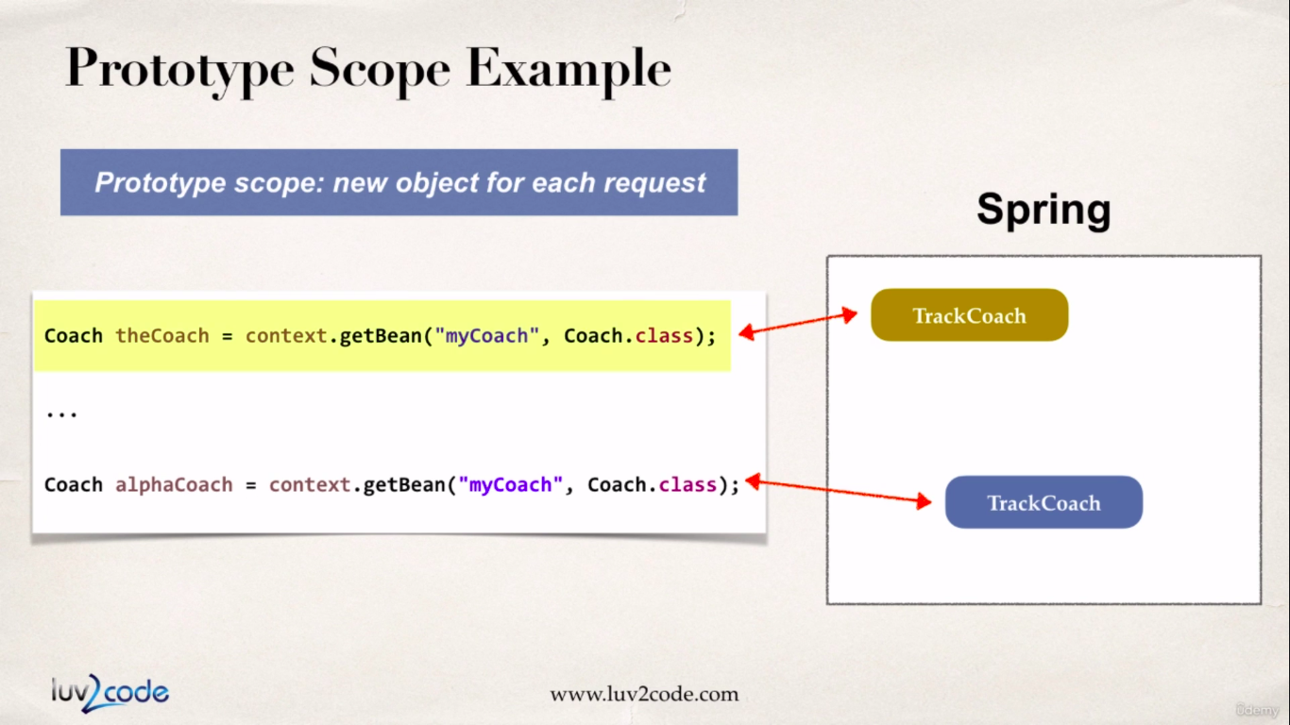

This scope design is recommended if we want to maintain state full data.

Let’s see an example.

**applicationContextSetterInjection.xml (xml config file)**

<?xml version=*"1.0"* encoding=*"UTF-8"*?>

<beans xmlns=*"http://www.springframework.org/schema/beans"*

xmlns:xsi=*"http://www.w3.org/2001/XMLSchema-instance"*

xmlns:context=*"http://www.springframework.org/schema/context"*

xsi:schemaLocation=*"http://www.springframework.org/schema/beans*

*http://www.springframework.org/schema/beans/spring-beans.xsd*

*http://www.springframework.org/schema/context*

*http://www.springframework.org/schema/context/spring-context.xsd"*>

<!-- Define your beans here -->

<!-- dependency bean -->

<bean id=*"myFortuneBean"*

class=*"com.busybox.setterInjection.HappyFortuneService"*></bean>

<!-- define bean injection as prototype -->

<bean id=*"myCoach"* class=*"com.busybox.setterInjection.TrackCoach"*

scope=*"prototype"*>

<!-- setup setter injection -->

<property name=*"fortuneService"* ref=*"myFortuneBean"*></property>

</bean>

<bean id=*"baseBallCoach"*

class=*"com.busybox.setterInjection.BaseBallCoach"*>

<!-- setup setter injection -->

<property name=*"fortuneService"* ref=*"myFortuneBean"*></property>

</bean>

<!-- load the property file -->

<context:property-placeholder

location=*"classpath:sport.properties"* />

<bean id=*"cricketCoach"*

class=*"com.busybox.setterInjection.CricketCoach"*>

<!-- set up setter injection -->

<property name=*"fortuneService"* ref=*"myFortuneBean"*></property>

<!-- injection for email id literal value -->

<!-- <property name="emailAddress" value="busyboxhere@gmail.com"></property> -->

<!-- injection for phone number literal value -->

<!-- <property name="phoneNumber" value="8847848036"></property> -->

<property name=*"phoneNumber"* value=*"${phoneNumber}"*></property>

<property name=*"emailAddress"* value=*"${emailAddress}"*></property>

</bean>

</beans>

**SetterInjectionDriver.java :**

**package** com.busybox.setterInjection;

**import** org.springframework.context.support.ClassPathXmlApplicationContext;

**public** **class** SetterInjectionDriver {

**public** **static** **void** main(String[] args) {

ClassPathXmlApplicationContext context = **new** ClassPathXmlApplicationContext(

"applicationContextSetterInjection.xml");

Coach trackCoach = context.getBean("myCoach", TrackCoach.**class**);

// check for single tone scope by comparing trackCoach1 and trackCoach2

Coach trackCoach1 = context.getBean("myCoach", TrackCoach.**class**);

Coach trackCoach2 = context.getBean("myCoach", TrackCoach.**class**);

Coach baseballCoach = context.getBean("baseBallCoach", BaseBallCoach.**class**);

CricketCoach cricketCoach = context.getBean("cricketCoach", CricketCoach.**class**);

System.***out***.println(trackCoach.getDailyWorkout());

System.***out***.println(trackCoach.getDailyFortune());

System.***out***.println(baseballCoach.getDailyWorkout());

System.***out***.println(baseballCoach.getDailyFortune());

System.***out***.println(cricketCoach.getDailyWorkout());

System.***out***.println(cricketCoach.getDailyFortune());

System.***out***.println(cricketCoach.getEmailAddress());

System.***out***.println(cricketCoach.getPhoneNumber());

System.***out***.println("is trackCoach1==trackCoach2 ==> " + (trackCoach1 == trackCoach2));

System.***out***.println("trackCoach1 memory address : " + trackCoach1);

System.***out***.println("trackCoach2 memory address : " + trackCoach2);

context.close();

}

}

output :

is trackCoach1==trackCoach2 ==> false

trackCoach1 memory address : com.busybox.setterInjection.TrackCoach@52719fb6

trackCoach2 memory address : com.busybox.setterInjection.TrackCoach@3012646b

As we can see from the output the references are different and the bean references are completely.

Below are some other possible scopes for beans which we will see in the spring mvc section.

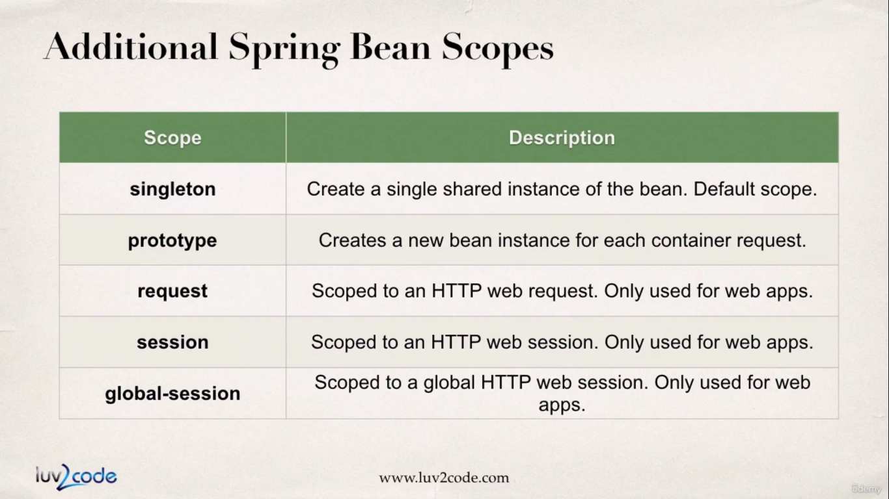

Bean Life Cycle Methods

When the bean container starts, there are couple of things that happen. The beans are instantiated, then the actual dependencies are injected, next we have some **Internal Spring Processing.** After this we have option for adding our custom initialization code. In this initialization we can call business logic codes and manage resources like (db connection, sockets and files etc)

At this point the bean is ready to use and we can call methods on it.

When we close the context by calling ‘context.close()’ the spring container shuts down. At this point we have an option to call our own custom destroy method, in this destruction we can call business logic codes and manage cleaning up resources like (db connection, sockets and files etc .After this the entire bean cycle is over and the application shuts down.

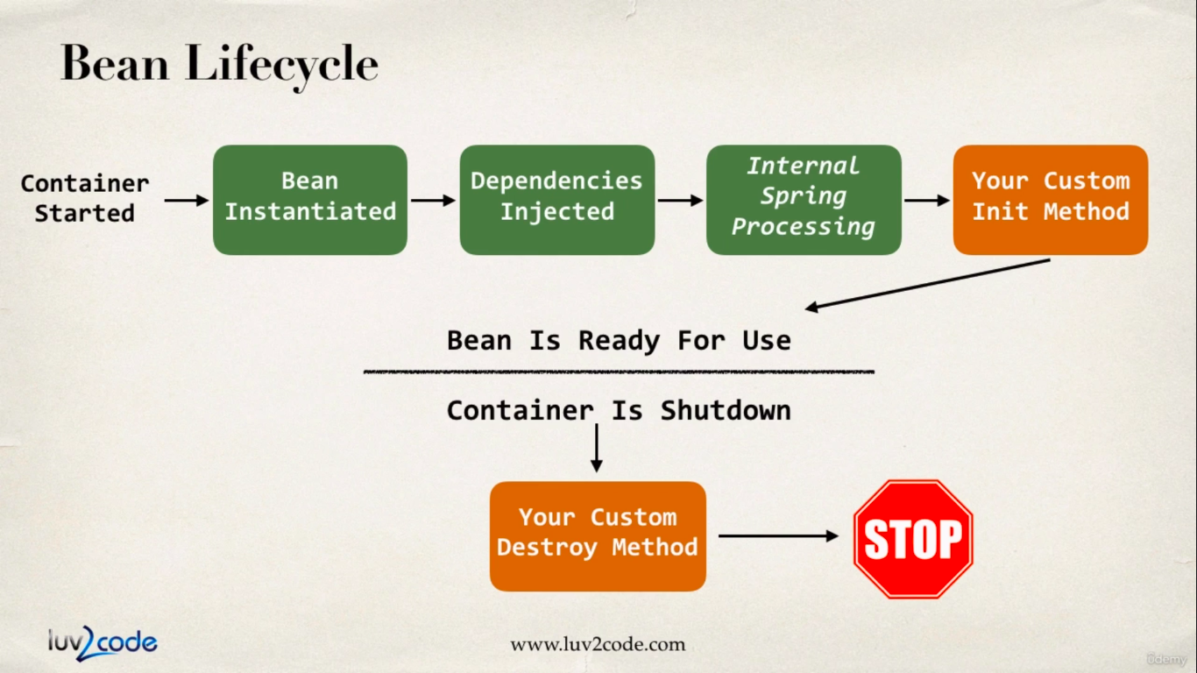

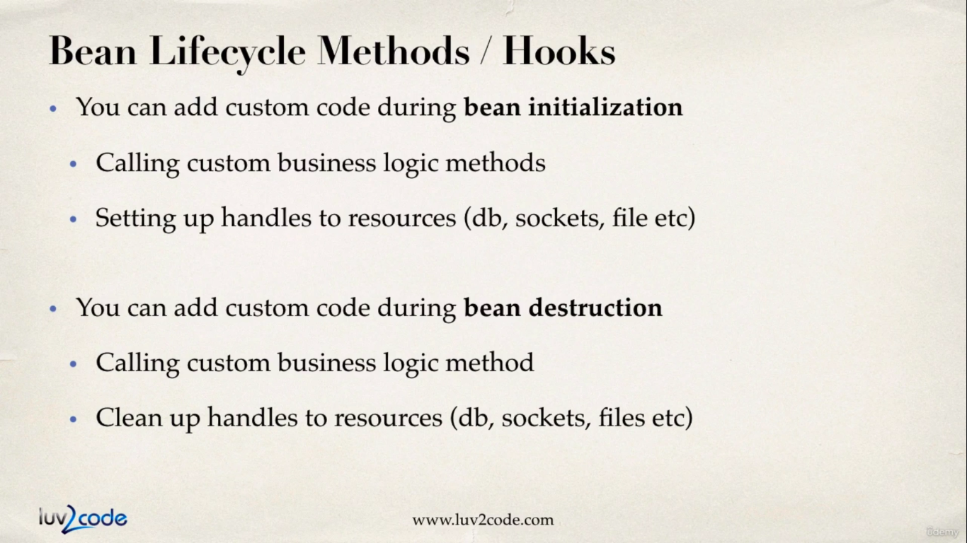

**Init : method Configuration**

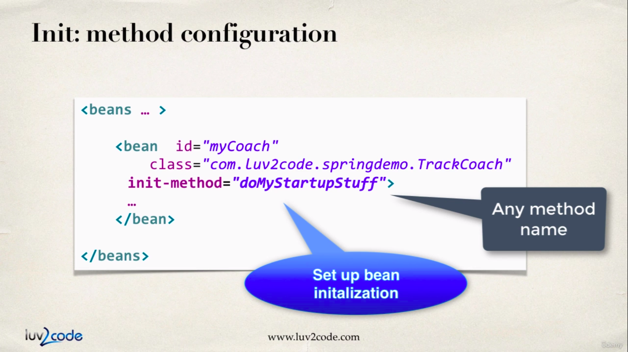

**destroy method configuration :**

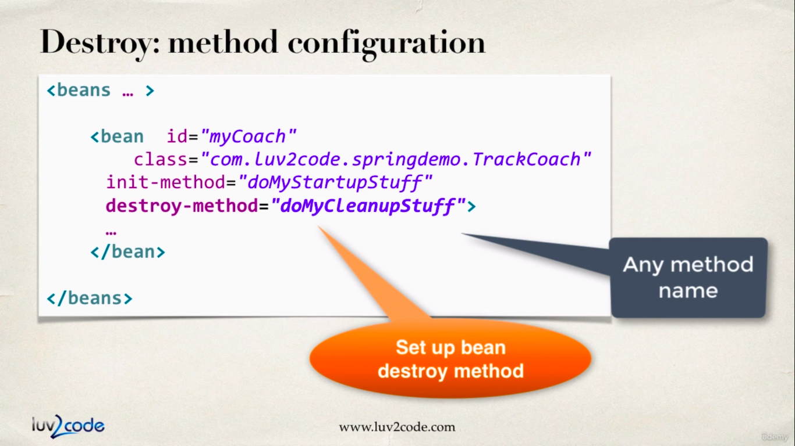

Now let’s consider the example below :

First we will create init and destroy methods inside the TrackCoach.java file.

TrackCoach.java :

**package** com.busybox.setterInjection;

**public** **class** TrackCoach **implements** Coach {

// define a private field for dependency

**private** FortuneService fortuneService;

**public** TrackCoach() {

// **TODO** Auto-generated constructor stub

}

// define a setter method for dependency injection

**public** **void** setFortuneService(FortuneService fortuneService) {

**this**.fortuneService = fortuneService;

}

@Override

**public** String getDailyWorkout() {

**return** "Run a hard 5k";

}

@Override

**public** String getDailyFortune() {

// **TODO** Auto-generated method stub

**return** **this**.fortuneService.getFortune();

}

// add a bean life cycle init method

**void** beanInitHook() {

System.***out***.println("beanInitHook()");

}

// add a bean life cycle destroy method

**void** beanDestroyHook() {

System.***out***.println("beanDestroyHook()");

}

}

Now as shown in the previous configurations we have to wire these methods inside the xml config file. This is shown below :

**applicationContextSetterInjection.xml**

<?xml version=*"1.0"* encoding=*"UTF-8"*?>

<beans xmlns=*"http://www.springframework.org/schema/beans"*

xmlns:xsi=*"http://www.w3.org/2001/XMLSchema-instance"*

xmlns:context=*"http://www.springframework.org/schema/context"*

xsi:schemaLocation=*"http://www.springframework.org/schema/beans*

*http://www.springframework.org/schema/beans/spring-beans.xsd*

*http://www.springframework.org/schema/context*

*http://www.springframework.org/schema/context/spring-context.xsd"*>

<!-- Define your beans here -->

<!-- dependency bean -->

<bean id=*"myFortuneBean"*

class=*"com.busybox.setterInjection.HappyFortuneService"*></bean>

<!-- define bean injection as prototype -->

<bean id=*"myCoach"* class=*"com.busybox.setterInjection.TrackCoach"*

init-method=*"beanInitHook"* destroy-method=*"beanDestroyHook"*>

<!-- setup setter injection -->

<property name=*"fortuneService"* ref=*"myFortuneBean"*></property>

</bean>

<bean id=*"baseBallCoach"*

class=*"com.busybox.setterInjection.BaseBallCoach"*>

<!-- setup setter injection -->

<property name=*"fortuneService"* ref=*"myFortuneBean"*></property>

</bean>

<!-- load the property file -->

<context:property-placeholder

location=*"classpath:sport.properties"* />

<bean id=*"cricketCoach"*

class=*"com.busybox.setterInjection.CricketCoach"*>

<!-- set up setter injection -->

<property name=*"fortuneService"* ref=*"myFortuneBean"*></property>

<!-- injection for email id literal value -->

<!-- <property name="emailAddress" value="busyboxhere@gmail.com"></property> -->

<!-- injection for phone number literal value -->

<!-- <property name="phoneNumber" value="8847848036"></property> -->

<property name=*"phoneNumber"* value=*"${phoneNumber}"*></property>

<property name=*"emailAddress"* value=*"${emailAddress}"*></property>

</bean>

</beans>

Now we have to create a driver class which will contain the main() method. This is where we retrieve the bean and the life cycle hook methods should execute.

**BeanScopeLifeCycleDriver.java :**

**package** com.busybox.setterInjection;

**import** org.springframework.context.support.ClassPathXmlApplicationContext;

**public** **class** BeanScopeLifeCycleDriver {

**public** **static** **void** main(String[] args) {

// **TODO** Auto-generated method stub

ClassPathXmlApplicationContext context = **new** ClassPathXmlApplicationContext("applicationContextSetterInjection.xml");

Coach trackCoach = context.getBean("myCoach",TrackCoach.**class**);

context.close();

}

}

output :

beanInitHook()

beanDestroyHook()

**Special Note about init and destroy Method Signatures :**

1. **Access modifier :** The method can have any access modifier (public, protected, private)
2. **Return type :** The method can have any return type. However, "void' is most commonly used. If you give a return type just note that you will not be able to capture the return value. As a result, "void" is commonly used.
3. **Method name :** The method can have any method name.
4. **Arguments :** The method cannot accept any arguments. The method should be *no-arg*.

**Special Note about Destroy Life cycle and Prototype Scope**

There is a subtle point we need to be aware of with "prototype" scoped beans. ***For "prototype" scoped beans, Spring does not call the destroy method.***

**In contrast to the other scopes, Spring does not manage the complete lifecycle of a prototype bean :** the container instantiates, configures, and otherwise assembles a prototype object, and hands it to the client, with no further record of that prototype instance.

Thus, although initialization lifecycle callback methods are called on all objects regardless of scope, **in the case of prototypes, configured destruction lifecycle callbacks are not called**. The client code must clean up prototype-scoped objects and release expensive resources that the prototype bean(s) are holding.

This also applies to both XML configuration and Annotation-based configuration.

The class whose bean injection scope is configured as “prototype” must implement an interface **DisposableBean** which contains a “destroy()” method

We can destroy prototype beans but custom coding is required. Consider the development stops below :

1. Create a custom bean processor. This bean processor will keep track of prototype scoped beans. During shutdown it will call the destroy() method on the prototype scoped beans. The custom processor should be configured in the spring config file.

<!-- Bean custom processor to handle calling destroy methods on prototype

scoped beans -->

<bean id=*"customProcessor"*

class=*"com.luv2code.springdemo.MyCustomBeanProcessor"*>

</bean>

1. The prototype scoped beans MUST implement the DisposableBean interface. This interface defines a "destroy()" method.
2. The Spring configuration does not require use the destroy-method attribute. You can safely remove it.

<?xml version=*"1.0"* encoding=*"UTF-8"*?>

<beans xmlns=*"http://www.springframework.org/schema/beans"*

xmlns:xsi=*"http://www.w3.org/2001/XMLSchema-instance"*

xmlns:context=*"http://www.springframework.org/schema/context"*

xsi:schemaLocation=*"http://www.springframework.org/schema/beans*

*http://www.springframework.org/schema/beans/spring-beans.xsd*

*http://www.springframework.org/schema/context*

*http://www.springframework.org/schema/context/spring-context.xsd"*>

<!-- Define your beans here -->

<!-- dependency bean -->

<bean id=*"myFortuneBean"*

class=*"com.busybox.setterInjection.HappyFortuneService"*></bean>

<!-- define bean injection as prototype -->

<!-- the scope is prototype for TrackCoach Bean the destroy-method hook will not be called -->

<bean id=*"myCoach"* class=*"com.busybox.setterInjection.TrackCoach"*

init-method=*"beanInitHook"* destroy-method=*"beanDestroyHook"* scope=*"prototype"*>

<!-- setup setter injection -->

<property name=*"fortuneService"* ref=*"myFortuneBean"*></property>

</bean>

<bean id=*"baseBallCoach"*

class=*"com.busybox.setterInjection.BaseBallCoach"*>

<!-- setup setter injection -->

<property name=*"fortuneService"* ref=*"myFortuneBean"*></property>

</bean>

<!-- load the property file -->

<context:property-placeholder

location=*"classpath:sport.properties"* />

<bean id=*"cricketCoach"*

class=*"com.busybox.setterInjection.CricketCoach"*>

<!-- set up setter injection -->

<property name=*"fortuneService"* ref=*"myFortuneBean"*></property>

<!-- injection for email id literal value -->

<!-- <property name="emailAddress" value="busyboxhere@gmail.com"></property> -->

<!-- injection for phone number literal value -->

<!-- <property name="phoneNumber" value="8847848036"></property> -->

<property name=*"phoneNumber"* value=*"${phoneNumber}"*></property>

<property name=*"emailAddress"* value=*"${emailAddress}"*></property>

</bean>

</beans>